**Batch: B-3 Roll No.: 16010122177**

**Experiment / assignment / tutorial No. 3**

**Grade: AA / AB / BB / BC / CC / CD /DD**

**Signature of the Staff In-charge with date**

|  |
| --- |
| **Title: :** Implementation of Database in SQL -DDL |

**Objective:** Define/modify database definitions with proper constraints

_____________________________________________________________

**Expected Outcome of Experiment:**

CO 2: Convert entity-relationship diagrams into relational tables, populate a relational

database and formulate SQL queries on the data Use SQL for creation and query the database.

CO 3: Define and apply integrity constraints and improve database design using normalization techniques.

_____________________________________________________________

_____________________________________________________________

**Pre Lab/ Prior Concepts**:

Resources used: Postgresql

**Theory:** The set of relations in a database must be specifies to the system by means of a data definition language (DDL). The SQL DDL allows specification of not only a set of relations but also specific information about the relation including,

1. The schema for each relation
2. The domain of values associated with each attribute
3. The integrity constraints
4. The set of indices to be maintained for each relation
5. The security and authorization information for each relation
6. The physical storage structure of each relation on disk

**Syntax Create Table:**

create table employee(ssn,fname varchar(10), mname varchar(10), lname varchar(10), desg varchar(20), gender varchar(5), addr varchar(20), bdate datetime, sal float,primary key(ssn));

create table manages(ssn int, dept_code int, start_dt datetime, foreign key(ssn)

create table manages(ssn int, dept_code int, start_dt datetime, foreign key(ssn)

references employee, foreign key(dept_code) refrences department, key(ssn,dept_code) ) on delete set null;primary

**Data Constraints**

Business managers of the organization determine a set of rules that must be applied before the data is stored in the database. The application of such rules on raw data ensures **data integrity**.

**Eg:-** An employee belonging to the Sales department cannot have a salary higher than Rs. 1000.

An employee has an unique identification number.

**Applying Data Constraints**

Oracle permits data constraints to be attached to table columns using SQL syntax. Constraints can be attached to table columns using

Alter table

**Unique Constraint**

**Unique Constraint- At column level Syntax**

**<ColumnName><Datatype>(<size>)**

**UNIQUE Unique Constraint- At table level**

**CREATE TABLE<TableName>(**

**<ColumnName><Datatype>(<size>)**

**<ColumnName><Datatype>(<size>)**

**<Columnname><Datatype>(<size>) UNIQUE(<ColumnName1>,<ColumnName2>);**

**Implementation Details (Problem Statement, Query and Screenshots of Results):**

**Problem Statement -** A system that manages the post-production activities of movies. The system should keep track of information related to ratings, revenue and other post-production tasks. It needs to store details about movies, including their titles, release dates, and genres. Additionally, capture information about the professionals involved in post-production, such as actors, producers and directors. Consider relationships between movies and the individuals working on their post-production, ensuring that the system can efficiently track and manage the post-production workflow for multiple movies simultaneously.

**Query**

Movie

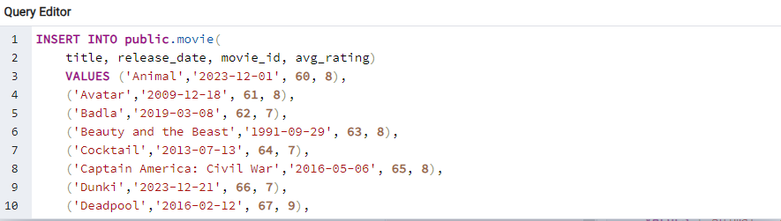

Person

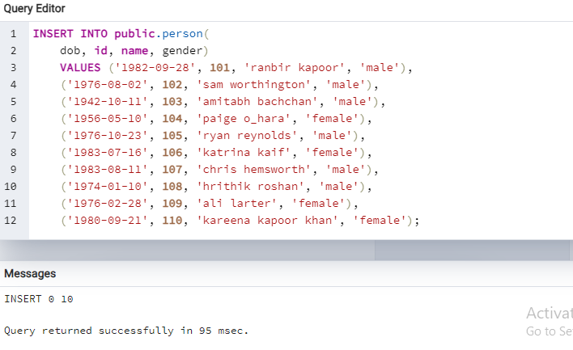

Monthly Revenue

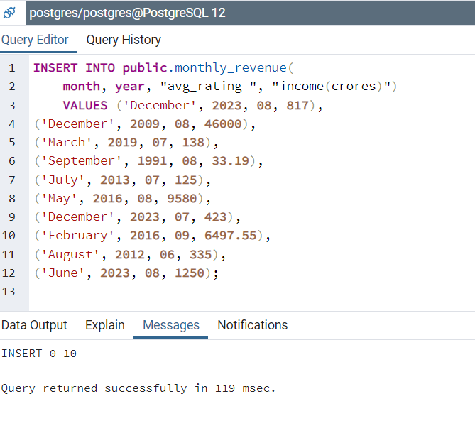

User

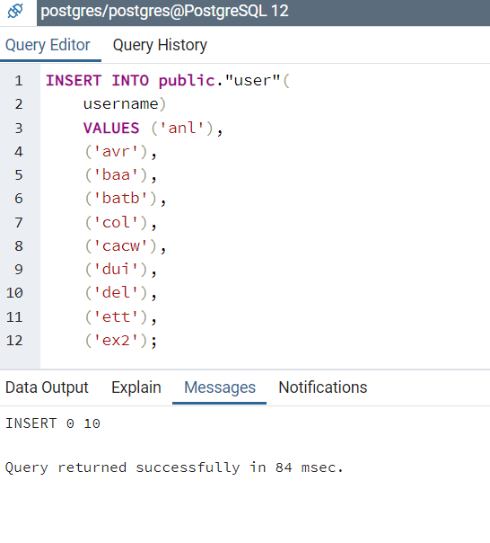

Genre

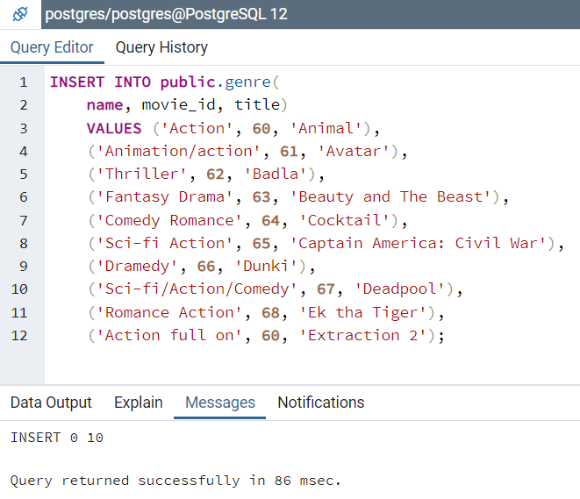

Rating

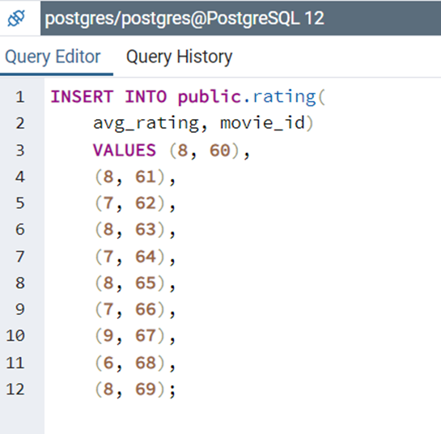

**Results**

Movie

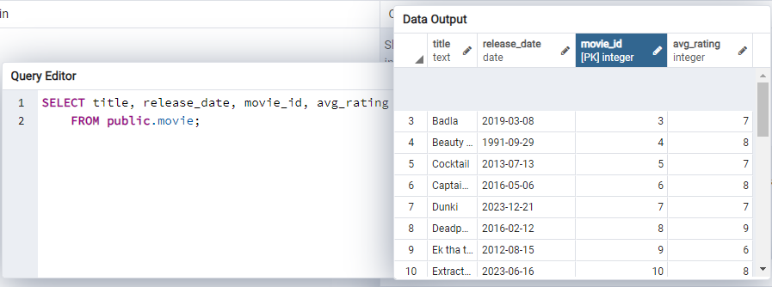

Person

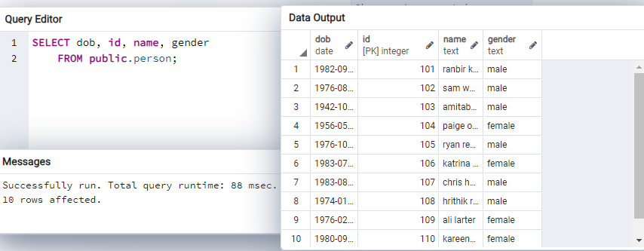

Monthly Revenue

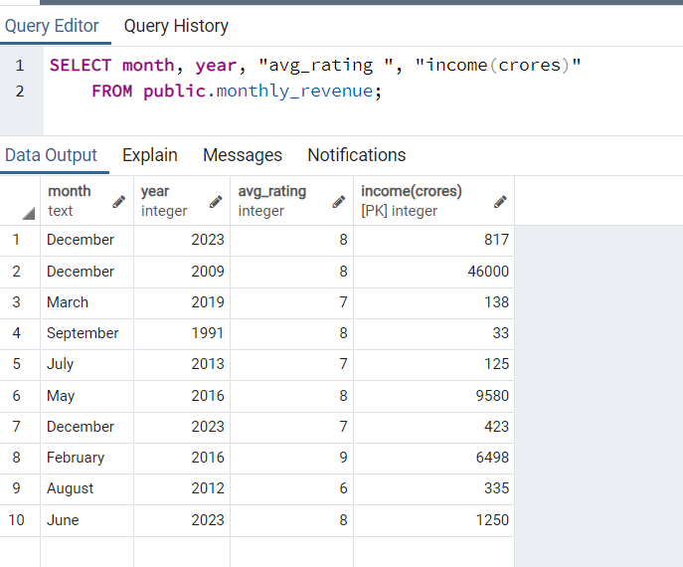

User

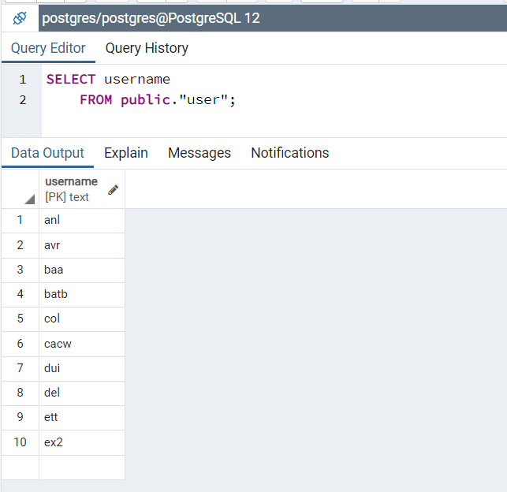

Genre

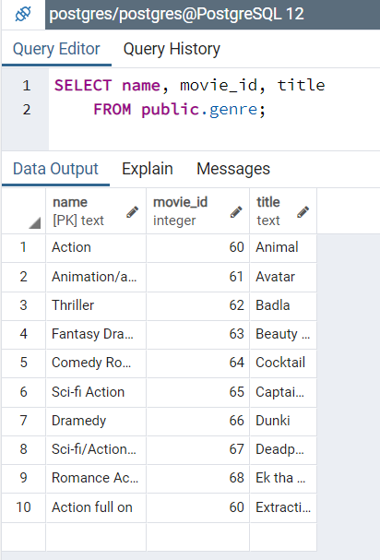

Rating

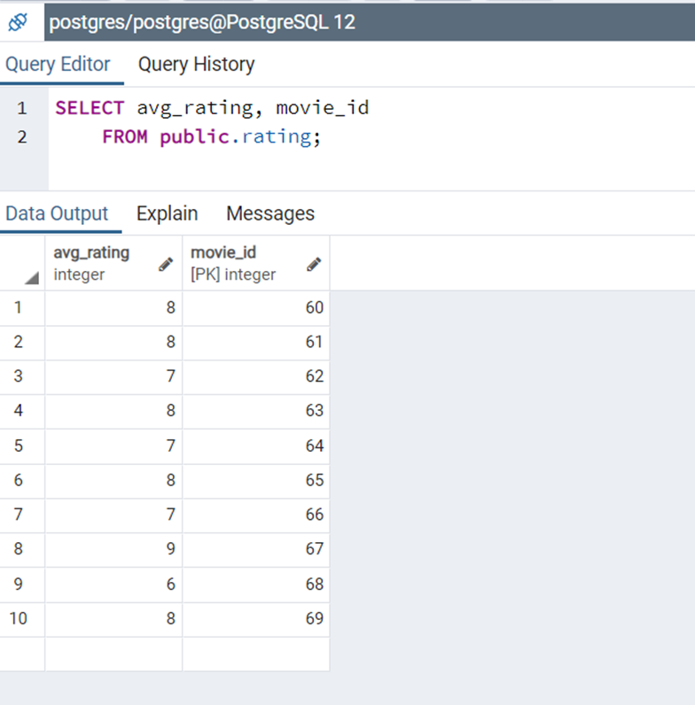

**Post Lab Questions:**

1. **Explain in brief the following terms:**
2. **Database:** - A database is an organized collection of structured data or information, typically stored electronically in a computer system. It is designed to efficiently manage, retrieve, and update data. Databases are commonly used in various applications such as websites, business systems, scientific research, and more. They provide mechanisms for storing, organizing, and accessing data in a structured manner, allowing users to perform operations like querying, updating, and deleting data.
3. **Types of databases:-** There are several types of databases, each designed to cater to specific requirements and use cases. Some common types include:

* **Relational Databases**
* **NoSQL Databases**
* **Document Stores**
* **Graph Databases**
* **Columnar Databases**

1. **SQL Data Types**

SQL (Structured Query Language) data types define the type of data that a column can hold in a relational database. These data types ensure data integrity and efficiency in storage and manipulation. Common SQL data types include:

**Numeric:** Integers (INT, SMALLINT, BIGINT), Floating-point numbers (FLOAT, REAL, DOUBLE), Decimal numbers (DECIMAL, NUMERIC).

**Character Strings:** Fixed-length strings (CHAR), Variable-length strings (VARCHAR), Text strings (TEXT).

**Date and Time:** DATE, TIME, DATETIME, TIMESTAMP.

**Boolean:** BOOLEAN.

**Binary Large Objects:** BLOB (Binary Large Object), CLOB (Character Large Object).

1. **What are the different commands to:**
2. **Delete an entire table.**

**DROP TABLE table_name;**

1. **To view a database.**

**\l**

**SELECT datname FROM pg_database;**

1. **To select & view all the columns.**

**SELECT * FROM table_name;**

1. **For the given ER model, using DDL command: Write syntax to create CREATE Tables with all possible integrity constraints.**

# Problem Statement:

# A small accounting firm wants a simple HR application that will help it to keep track of its employees, their positions, allowances, salary scales, and which company vehicles their employees drive. The application must keep track of all the positions at the firm, the employees filling these positions, the allowances for these positions, the salary scales for these positions, and the company vehicles assigned to these positions.

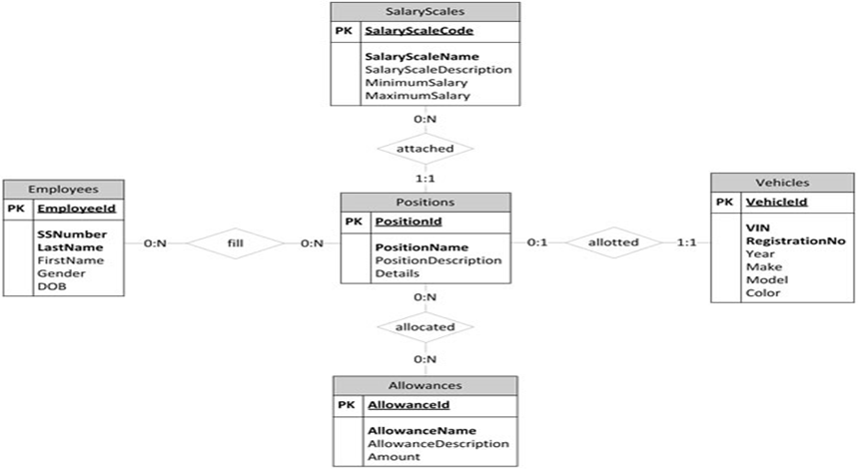

CREATE DATABASE hr;

CREATE TABLE Positions (  positionID varchar[10] PRIMARY KEY,  positionName varchar[20],

positionDescription varchar[500]

);

CREATE TABLE SalaryScales (

SalaryScaleCode int PRIMARY KEY,

  SalaryScaleName varchar[100],  Description varchar[200],  minSalary int,

maxSalary int

);

CREATE TABLE EMPLOYEES (

EmployeeID int PRIMARY KEY,

SSNo int,

LastName varchar[20],

FirstName varchar[20],

Gender varchar[10],

DOB date

);

CREATE TABLE ALLOWANCES (

  AllowanceID int PRIMARY KEY,  AllowanceName varchar[20],

  description varchar[100],  amount int

);

CREATE TABLE VEHICLE (

VehicleID int PRIMARY KEY,

VIN int,

RegNo int,

Years date,

Make varchar[20],

Model varchar[20],

  Color varchar[10] );

**Conclusion:**

This experiment enabled a systematic understanding of Data requirements of application and EER diagram design, laying the groundwork for effective and optimized database development